**Daily Scrum or Standup Meeting**

Team name: ________Group 2_________________

Scrum Master: ______Emily_________________

Date:________11/9_______________________

| **Team Member** | **What did you do since the last scrum?** | **What do you plan to do before the next scrum?** | **What obstacles do you have?** |
| --- | --- | --- | --- |
| Emily | Waited to be able to start my remaining task | Implement customer pays for order | Other classes |
| Karl | Create employee view that displays orders | Fix view customization screen | Git and coordination |
| Maris | Created Shopping cart view | Write logic for customizing drink | coordinating with others on same issue and know how |
|  |  |  |  |
|  |  |  |  |

# Burndown

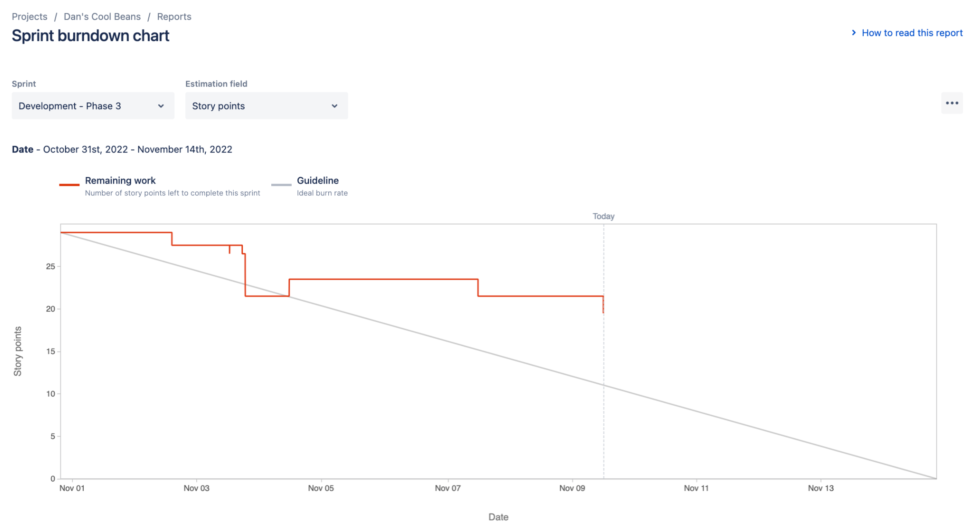

# Screenshot of you project board

